 | BAHRIA UNIVERSITY, (Karachi Campus)  Department of Software Engineering  Assignment – Spring 2021
COURSE TITLE: Occupational Health & Safety
COURSE CODE: ENV-101

Class: BSE 2 B Shift: Morning
Course Instructor: Muhammad Irfan Time Allowed: Whole Semester
Max. Marks: 15 Marks

Assignment 1: Describe the comparison between WHMIS, HAZCOM 2012 and GHS Hazard Classification and Communication System? [05 marks]
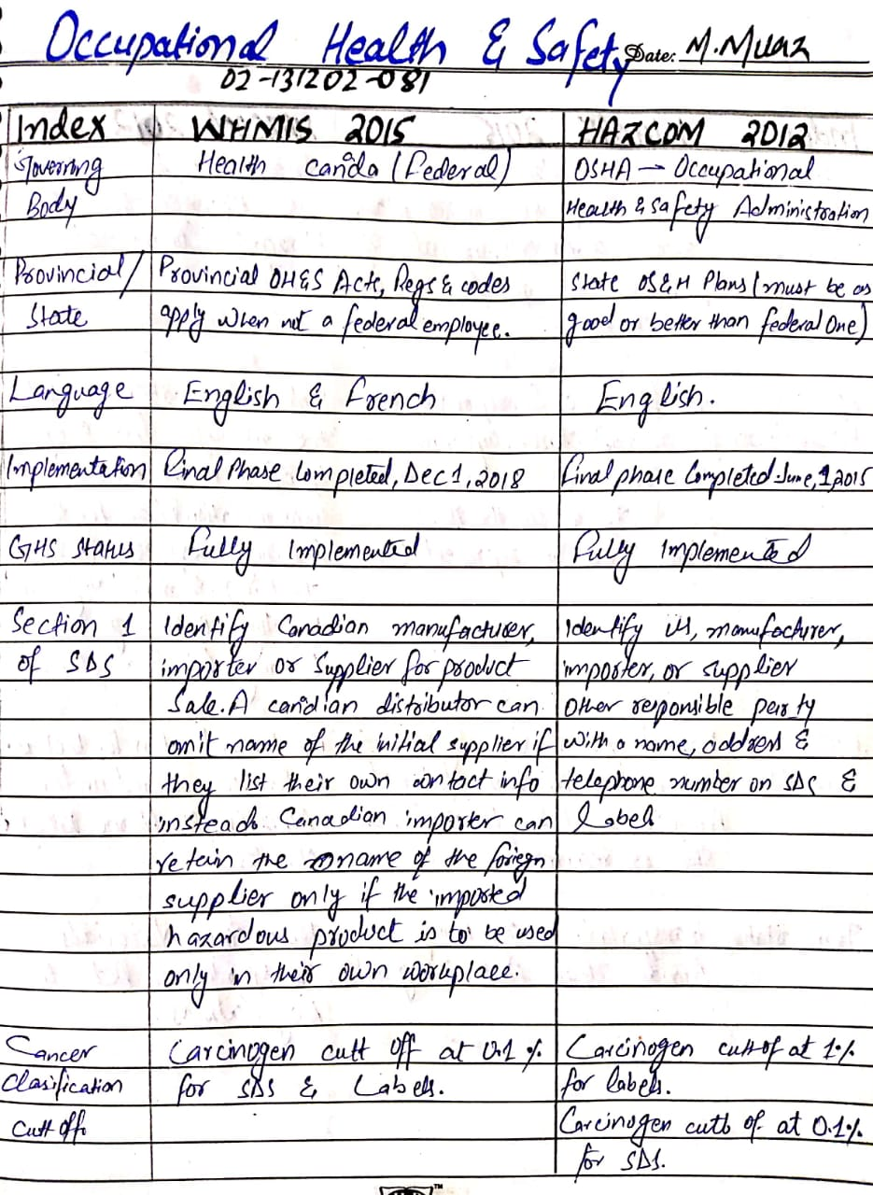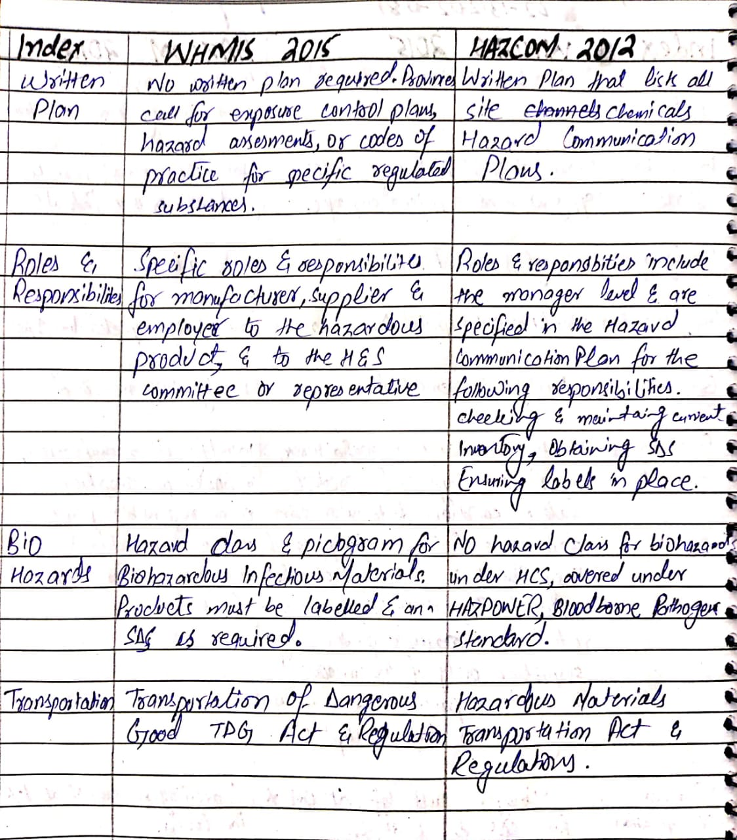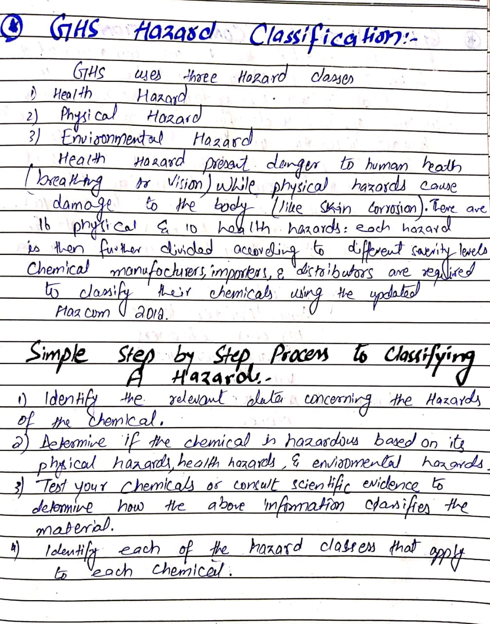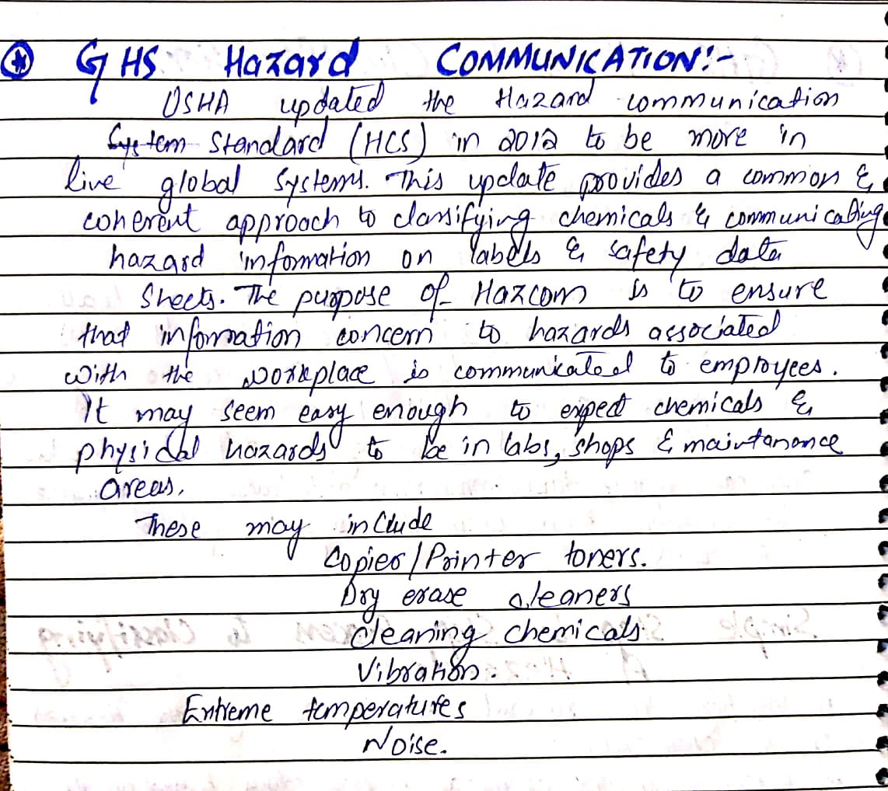
(CLO-1)
(Handwritten) (29/03/2021 – 12/04/2021: 2 weeks)

